RATING PREDICTION IN RECOMMENDATION SYSTEMS USING GNN

Dr. Swathi Sowmya Bavirthi, Department of IT, Chaitanya Bharathi Institute of Technology(A) Amogh Jonnalagadda , Balu Chander D , Bharghav Vuppu , Chaitanya Bharathi Institute of Technology(A)

# ABSTRACT

Recommendation systems were developed to solve the problem of users' information overload who spend a lot of time searching for relevant information. Graph Neural Networks (GNNs) have shown to be effective when studying graph data, which integrates information about nodes and topological structure. Social recommendation data is also a type of graph data that can be displayed as user and user social graphs and user and item graphs, making GNNs a promising opportunity to advance social recommendation. However, constructing recommender systems using GNNs can be challenging as users participate in both user-item and user-user graphs, and their opinions about things are included in user-item graphs. Moreover, users' social relationships take various forms. A unique framework is addressed to overcome these problems called GraphRec which has been proposed for rating prediction in social recommendations. GraphRec models two graphs with heterogeneous strengths and provides a methodical strategy to simultaneously record interactions and viewpoints in the user-item graph. The effectiveness of the proposed framework is proven through thorough testing on a real-world dataset.

# KEYWORDS

GNN, GrapRec, Social Recommendation, Collaborative Filtering, Aggregation, Knowledge Graph

# INTRODUCTION

Users need technologies that can help them filter useful information from a large amount of noisy input in today's world of information overload [9], [10]. Recommender systems are frequently employed as the most efficient method to address the issue of overloading of information in a variety of user- centric websites, such as Amazon, Taobao and social networking (e.g., Facebook, Instagram) sites[11]. These programmes are designed to offer a customised list of products that a customer is most likely to click on or buy [11],[12]. The best and popular techniques in contemporary recommendation systems, collaborative filtering (CF), predicts users' preferences for things based on their past interactions with the items[10],[13]. The incorporation of social relationships into recommendation systems, along with user-item interactions, a lot of attention is being received in recent years[14],[15],[16]. The creation of these social recommendation systems has been based on the phenomena of referral marketing, which is widely acknowledged as the most successful method for product recommendations.

Users may specifically get information from and share it with their friends, relatives, classmates, and coworkers. In order to sort information and identify their interests for certain items, consumers can benefit from their underlying social ties. As a result, by using users' social networks, several recommendation systems have seen considerable speed gains. When learning from graph data, deep neural network models have demonstrated outstanding success[18]. In order to develop meaningful representations from graph data based on node attributes and the graph's structure, Graph Neural Networks, which are deep neural network designs, have been suggested [19], [20], [21], [22]. The core concept underlying GNNs is to repeatedly gather feature data from neighboring local graphs using deep neural networks, while aggregation and transformation operations enable the transmission of node data all through the graph structure.

Due to their natural integration of node and topological structure information, GNNs have been demonstrated to be efficient representation learning approaches for graph data [25], [20], [21]. a variety of applications, such as knowledge graphs [23], [24], have utilized GNNs,computer vision [25], [26], and text analysis [27].A user-item network for interactions between user-items and a social graph for user-to-user relationships are two explicit graphs that may naturally be used to describe data in social recommendations. These two types of user interactions can provide more accurate indications of user preferences from various angles.

The relationships between things are essential for offering an extra source of data that might be utilised to profile objects alongside to these explicit links in social recommendations. This is because things are not independent and are more likely to be connected or comparable to one another [28], [29].

Customers who bought an Apple iPhone XS, for instance, are probably interested in buying Apple Air Pods since they have similar characteristics (i.e., they were created by Apple Inc.). In a same vein, MacOS laptops including the MacBook Air, MacBook Pro are grouped together for comparison due to their comparable capabilities. In reality, the links between objects have made several crucial applications possible, including moving between related items, finding brand-new or obscure goods, and finding interesting item pairings is made simpler [28]. Customers of Amazon are able to switch between items in particular because to relations like "users who purchased X also purchased Y" and "users who observed X also viewed Y." Another approach to displaying these relationships between objects seems to be an item-item graph. Therefore, it is desirable to take into account their interactions in order to improve the learning of representation of things in social recommendations.

The information in rating prediction can be shown as a three-graph heterogeneous graph. Users are active in both explicit networks, connecting social networks and user-item graphs, while items establish relationships within the user and item , item and item graphs. It is most important to include both items and its users representation rather than merely understanding them from the user and item graph in order to enhance the items and users representations. The item-item graph and the social graph should both be included into the process of refining the representations of item and user, respectively.

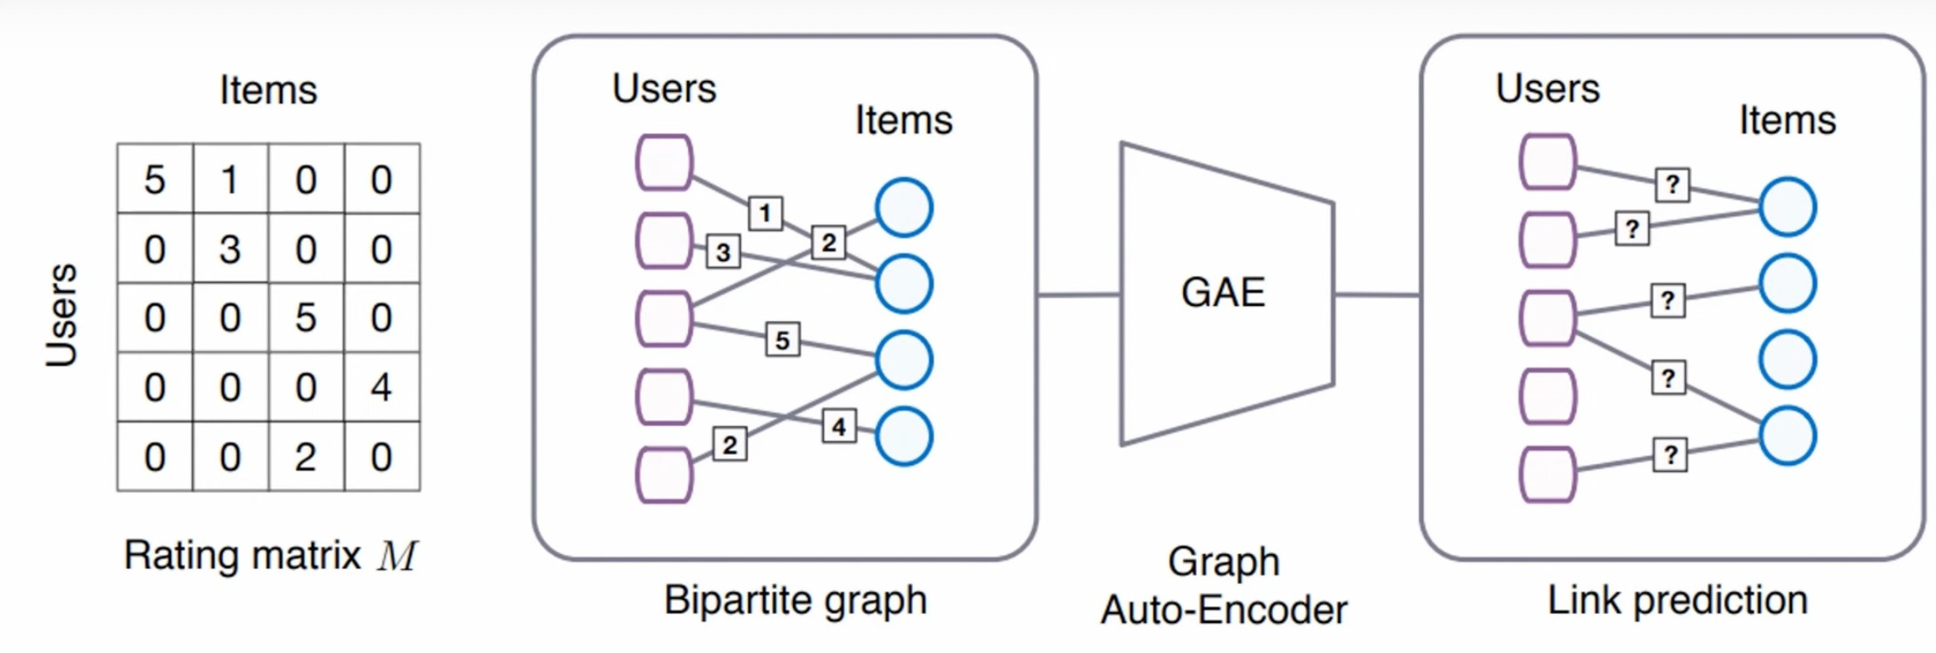

## Figure 1. GNN Model extracted from [1]

It is required to study the representations of users and objects in order to develop social recommendation systems. Due to their benefits, GNNs provide distinctive potential to enhance social recommendations.

There are various difficulties in creating social recommendation systems that use GNNs. How to merge information collected from the item and item graph, user and item graph, and social network to gain a more thorough knowledge of user and item representations is one of the primary challenges.

How to include user feedback, which can be expressed as rating scores, in the user-item graph presents another challenge. In order to overcome these difficulties, the authors of this research provide a unique GNN that can coherently represent the data of graph as well as a guiding principled approach for concurrently collecting interactions and opinion in the user and item graph. A mathematical method is also offered for considering the strengths of various social ties. A variety of datasets including real world scenarios are used to test the framework's performance in rating prediction tasks.

# RELATED WORK

An overview of deep neural network, advanced graph neural network, and social recommendation methods is provided in this section. Utilizing social networks for recommendations has drawn a lot of attention lately [15], [36]. According to social correlation theories, a user's choice may be impacted by those closest to them (neighbors) [32], [33]. The identical latent user- feature matrix, ratings, and social interactions are utilized in SoRec's co-factorization approach [35]. TrustMF [36] takes into account social trust networks and divides users into the recognized space and the neutral space, two low-dimensional spaces. Using a community recognition algorithm, SoDimRec [16] divides people into several clusters and generates suggestions based on the variety of social ties and weak dependency links. Surveys have looked closely at social recommender systems [12].

In a number of disciplines, including computer vision, speech recognition, and Natural language processing, models based on deep neural networks have had a substantial impact on developing effective feature representations. Deep neural networks have recently been utilised to represent music audio characteristics, textual item descriptions, and picture visual material for recommendations [31]. A Neural Collaborative Filtering framework was proposed by NeuMF [11] to learn irregular interactions between users and things.

Deep neural networks have just lately been applied to social recommendation systems. The NeuMF [11] paradigm for cross-domain social recommendation was expanded by NSCR [40], which suggests products from information domain to potential social network members. By employing an auto-encoder on ratings, DLMF [41] develops representations for initializing an existing matrix factorization. In order to create predictions, DeepSoR [37] combines social data about users' k-nearest neighbors from neural networks with a probabilistic matrix factorization.

The tasks utilizing artificial neural networks, such as DLMF [41] and DeepSoR [37], are the most pertinent to our research. To obtain representations for initializing an existing matrix factorization, DLMF [41] use an auto-encoder on ratings. In order to make predictions, DeepSoR [37] employs neural networks to combine social data about users' k-nearest neighbors into a statistical matrix factorization model. DeepSoR [37] proposes a two-stage trust-mindful recommendation process that orchestrates the client's advantages, their trust companions' preferences, as well as the impact of surrounding impacts, based on the matrix factorization method for proposals.

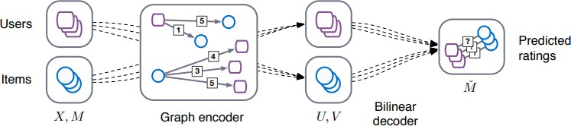

## Figure 2. Working of GNN model extracted from [1]

The ability of Graph Neural Networks (GNNs) to successfully train from graph-structured data has recently been demonstrated [18], [20], [21]. As a result, GNNs are a viable alternative for recommendations systems that involve user-item relationships, which are frequently graph data [38]. Many GNN-based models, including SR-MGCNN [42], GCMC [38], PinSage [19], NGCF [39], and MMGCN [43], have been suggested for recommendation tasks.

There have been significant advancements in the field of social recommendation utilizing GNNs, even though it has not garnered much attention. By adding social links between users, SocialGCN [1] employed GNNs to learn the social representations of individuals and things in a recommendation system. SRGNN [2] developed a framework that makes use of a recurrent neural network to represent the temporal nature of user-item interactions in a social network. A personalized interaction-based attention method was also created by PINA [3] to capture specific tastes of users in social networks.

In terms of recommendation systems, GNNs have demonstrated considerable promise, especially for data with graph structures like user-item interactions in social networks. More sophisticated GNN-based techniques are expected to be created for this domain as the field develops.

|  |  |  |  |  |  |  |
| --- | --- | --- | --- | --- | --- | --- |
| **Paper Title and Reference** | **Dataset** | **Model** | **Dataset**  **Size** | **Metric name** | **Metric value** | **Comparison** |
| Graph Convolutional Matrix Completion (2017) | YahooMusic Monti | GC-MC | 120 tracks of 30 second length | RMSE | 0.832 | GMC |
| Graph Neural Networks for Social Recommendation (2019) | Epinions | GraphRec | 75,879 nodes and 50,8837 edges. | MAE | 0.8168 | GraphRec |
| Neural Collaborative Filtering (2020) | Pinterest | NeuMF | 1million images | HR@10 | 0.8790 | NCF |
| Knowledge Graph Convolutional Networks for Recommender Systems (2021) | Yelp | KGCN | 1224M reviews | HR@10 | 0.8125 | KG |
| Neural Graph Collaborative Filtering (2021) | MovieLens 25M | NGCF | 250mb | Hits@10 | 0.7807 | HOP-Rec for CF |
| Session-based Recommendation with Graph Neural Networks (2021) | Gowalla | SR-GNN | 196,591 nodes and 950,327 edges. | HR@20 | 50.32 | STAMP |
| Coupled Graphs and Tensor Factorization for Recommender Systems and Community Detection (2021) | Digg | CGTF | 30Gb | NMI | 0.68 | CMTF |
| POI Neural-Rec Model via Graph Embedding Representation (2021) | Gowalla | DG-NeuRec | 196,591 nodes and 950,327 edges. | HR@20 | 0.7636 | SG-NeuRec |
| A Deep Graph Neural Network-based  Mechanism for Social Recommendations (2021) | Epinions | GNN-SoR | 75,879 nodes and 50,8837 edges. | MAE | 0.833 | SoR |

## Table 1. A Glimpse of research on social recommendations using GNN

The practicality of NSCR (Network-based Social Collaborative Filtering), a social recommender system, may be constrained by the fact that it needs users to have one or more social network accounts, such as those on Facebook, Twitter, or Instagram. SMR-MNRL, on the other hand, created a rating system for a multimodal heterogeneous network that uses social media data to propose films that are socially conscious. They used a random-walk-based learning technique with multimodal neural networks and employed recurrent and convolutional neural networks to figure out how to represent movie text descriptions and movie poster visuals.

It is crucial to remember that while NSCR and SMR-MNRL both handle the problem of social recommendations, their approaches are different. In contrast to SMR-MNRL, which utilizes multimodal neural networks to explicitly target social media-based movie recommendations, NSCR concentrates on cross-domain social recommendation for ranking metrics.

# RESEARCH METHODOLOGY

Figure 3 shows the architecture of the proposed model, which consists of three main parts: featuring users, featuring items, and making prediction. Given that users are engaged in both a social network and a user-item graph in social recommendation systems.

The first component, featuring user, seeks to learn users' hidden features from diverse angles. To analyze these two different networks, two aggregations are used: the item aggregation, which analyses user interactions with objects, and the social aggregation, which analyses user relationships in the social graph. User latent factors may be identified by merging information from the social and item spaces.

Featuring items, the second element, seeks to identify the latent variables in items. The user aggregation, which models how users' interactions with things reflect items, and the item2item aggregation, which enhances the representations of items from the item-item graph, are two aggregations that are offered to gather useful data across the user space and the item-to-item space. Data from both areas may be integrated to profile the latent variables in the final item.

The third element, making prediction, combines user and item modelling elements to utilize prediction to learn the model's parameters.

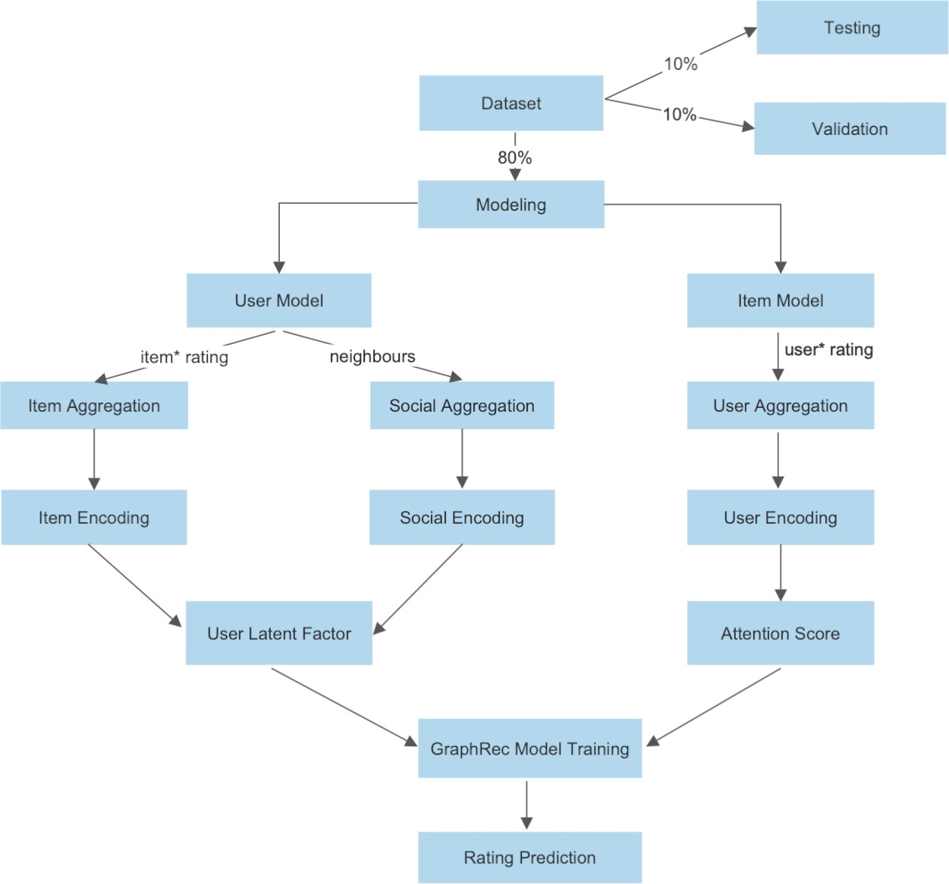

**Figure 3. Proposed Framework**

# Featuring users

How to successfully mix data from linked peers and the graph of users and items is a difficulty in user modelling, which tries to find latent variables that define users. One method includes extracting elements from both graphs using two different forms of aggregations. The social aggregation learns user latent components from the social network, whereas the main aggregation concentrates on items and retrieves latent factors from the user-item graph.

The two sets of variables are then joined to create total user latent variables. Aggregation of items, aggregation of linked peers i.e. social, and method of fusing user latent components from both space of item and social will all be covered in the parts that follow.

# Aggregation of items

The graph of users and item is used in a systematic method that models user latent variables through interactions and opinions. Users' views or ratings of the things are included in this graph along with the user’s relationships with the items. Aggregating of items may uncover the latent factor of the user in space of the item by considering the things that an UI (user interface) has interacted with and users' thoughts on those objects. This component may be used to enhance customized recommendations or other user-centered services since it records the preferences of the users and views in connection to the objects they have interacted with.

The aim of item aggregation is to learn the item space user latent factor hI by taking into account the things that a user interface ui has interacted with and the views of users on these items.To express this aggregate numerically, use the following function:

hIi =σ(W·AGGitems({xia,∀a∈C(i)})+b)

AGG items is the item aggregation function, C(i) is a group of items user ui interacts with, or ui's neighbours in the user-item network, and xia is a representation vector to express opinion-aware relationship between user ui and an item va. Additionally, W and b stand for an activation function that is nonlinear (i.e., a rectified linear unit) and the weight and biases of a neural network, respectively.

The MLP receives as input the combination of the item contained qa and its opinion embedded er. The MLP output depicts the following connection between ui and va:

xia = gv([qa ⊕ er])

A common aggregation function for AGGitems is the mean operator, which calculates the component-wise mean of the vectors in xia, a and C(i). This mean-based aggregate is shown to be a rough linear model of a localised spectral convolution in the following function:

hi =σ(W· αiaxia +b)

The inputs to the attention network are the embed pi of the target user ui and the opinion-aware representations of the interaction xia. The formal description of an attention system is as follows:

αia =w2 ·σ(W1 ·[xia ⊕pi]+b1)+b2

# Aggregation of linked peers of users

Users' choices could be impacted by or comparable to those of their socially linked peers, according to social correlations theories. In order to enhance user modelling, social data should be coupled with other user-centric aspects. Additionally, while learning latent components in the social space, the social links that users have with one another should be taken into consideration since these interactions might influence users' behaviors in the social graph. A mechanism for attention is developed to help characterize and collect social data about users in order to do this. This mechanism chooses representative social buddies. This method can enhance personalized suggestions or other user-focused services by capturing the impact of relationships on customer preferences and behavior.

To show user latent factors from a social perspective, it is advised to integrate the item-space user latent factors of nearby users from the social network. Utilising the social-space user latent factor of ui, hSi, the item-space user latent factors of users in ui's social neighbours N(i) are aggregated as follows:

n o

hSi =σ(W·AGGsocial( hIo,∀o∈N(i) )+b)

Another suitable aggregation algorithm for AGGsocial is the mean operator, that utilises the component-wise average of the vectors in hI, o, and N(i). This operator is supplied by the following function.

X

hS =σ(W· βhI+b)

Strong and weak links coexist in social networks, and those with strong connections are more inclined to share similar interests than those with weak ones. We may connect socially focused IO with hIO and aim the user embed PI as follows in order to replicate these users' tie strength and implement an attention mechanism with a two-layer neural network:

X

hS =σ(W· β hI+b)

β∗ = wT · σ(W · [hI ⊕ p ] + b ) + b βio = P exp(β∗ )

In order to better comprehend user latent factors, item-space user latent factors and social-space user latent factors should be taken into consideration together. This is because both the user-item graph and the social graph provide information about users from different angles. To construct the final user latent factor using a conventional MLP, the item-space user latent factor hIi and the social-space user latent factor hSi are mixed before being given into the MLP. Officially, the user latent factor hi for the user ui is described as:

c1 = hi ⊕hi

cu2=σ(W2·cu1+b2)

u hi=σ(Wl·cl−1+bl)

# Featuring Items

Item modelling, in which items are linked to users in the graph of users and items as well as to associated items in the item and item graph, is used to learn about item latent variables. Different viewpoints on how to discover item latent factors are presented in these two graphs. A technique similar to that used for user modelling is utilized to merge these viewpoints.

This approach uses two separate collections to learn two distinct latent components of the object from the two graphs. The graph of users and items is used for learning the latent factor in space of users through the first aggregation, also known as the aggregation of users. The second aggregation, the item2item collection, enables the extraction of latent item2item space item components from the item and item graph. These two components may be merged to produce the final item latent factors, that will improve the accuracy and effectiveness of customised recommendations or other services that are geared towards individual consumers.

# Aggregation of users

A technique akin to item aggregating is used to discover user hidden variables in item-space. In particular, data is acquired from every user who has engaged with a certain object, enabling a variety of viewpoints to be conveyed regarding that thing. The modelling of an object's latent variables can be aided by these user comments, which can disclose several characteristics of the same item. In order to do this, a basic user embedding pt-based user representation for interacting with opinions is presented. Additionally, a Multi-Layer Perceptron (MLP) is used for assessment embedding, allowing user-item rating ratings to be included into the model to further increase the precision of customized suggestions or other user-centric services.

A relationship from ut to vj with an opinion r uses an idea-aware interactions user representational fjt that is created from the basic user embedded pt and opinion embedding er using an MLP. The symbol gu stands for the function that integrates interaction and opinion data:

fjt=gu([pt⊕er])

The user-space item latent factor hUj should then be identified by integrating the opinion-aware interaction representation of users for item vj as our technique dictates in B(j). The user aggregation function is known as AGGusers, and it aggregates the opinion-aware interaction representations of users in fjt, t, and B(j). Therefore,

hU =σ(W·AGG ({f ,∀t∈B(j)})+b)

A two-layer neural attention network that has a distinction mechanism for the important weight jt of users is also introduced. This user attention jt is utilised to capture various impacts from interactions among users and things for learning the user-space item latent variables using fjt and qj as inputs.

X

hU =σ(W· μ f +b)

μ∗jt =w2T ·σ(W1 ·[fjt ⊕qj]+b1)+b2

μjt = P exp(μ∗ )

Since objects are not independent and have a tendency to be interconnected and connected, it is desirable to further investigate the latent components of the item from like or similar items. Therefore, item2item aggregation process is used to determine item2item-space item latent components. The item2item-space item latent factors of item vj, denoted by the acronym hVj, aggregate the user space item latent factors of items in item vj's similar or related items M(j), as illustrated below.

hVj =σ(W·AGGItem2item( hUk,∀k∈M(j) )+b)

where the item's M() "neighbours" in the item-item graph IG are subjected to the aggregation function AGGitem2item. Additionally, the important weight jk of related items is distinguished using a two-layer neural attention network as a method for attention,

X

hV =σ(W· κ hU+b)

κ∗jk =w2T ·σ(W1 ·[hUk ⊕qj]+b1)+b2

κjk = P ∗

exp(κ )

k∈M(j) jk

Finally, using a conventional MLP with hidden layers, integrate these two item representations (hUj and hVj) to get the final component's latent factor as follows:

h i

cv = hU ⊕hV

cv2 = σ(W2 · cv1 + b2)

zj = σ(Wl · cvl−1 + bl)

**4.6. Making Prediction**

The recommended tasks used to determine model parameters are described in this subsection. This study concentrates on the rating prediction task and utilizes the suggested GraphRec model among the other recommended tasks, such as item rating and rating prediction. The latent components of users and items (hi and zj) are concatenated as [hi zj] and put into MLP to create a rating prediction. This strategy enables the model to accurately predict rating by using both the user and item latent features.

g1=[hi⊕zj] g2=σ(W2·g1+b2)

...

gl−1 = σ(Wl · gl−1 + bl) r′ =wT·g (30) ij l−1

# EXPERIMENTAL EVALUATION

To verify the efficacy of the suggested rating prediction methods, this project makes use of a toy dataset.

Toy dataset ( Size 440KB ): The dataset consists of.

|  |  |
| --- | --- |
| Dataset | Toy Dataset |
| # 0f Users | 705 |
| # 0f Items | 1941 |
| # 0f Ratings | 8 |

## Table 2: Statistics of Toy Dataset

* User Lists: User's purchased history
* User Rating Lists: His/Her rating score
* Item Lists: User set who have interacted with the item.
* Item Rating Lists: The rating score of interacted users
* Social Friends Lists: User's connected neighbourhoods or friends
* Ratings List: Rating value from 0.5 to 4.0 (8 opinion embeddings).

Most often used metrics for assessing the precision of recommendation algorithms are MAE which is Mean Absolute Error and RMSE which is Root Mean Square Error. Better prediction accuracy is shown .when the MAE and RMSE values are low. The efficacy of the top suggestions in practise can be significantly impacted by even a little change in these measures.

A typical metric for assessing the accuracy of forecasts is the RMSE. Using the Euclidean distance, it calculates how much the predictions differ from the actual data. The amount of the residual (difference between what was predicted and facts) is calculated for each data point in order to determine RMSE. After determining the mean of the residuals and taking the square root of that mean, the standard deviation of the residual is derived for each data point. RMSE as it require accurate and better measurements at each and every point, it is most frequently used in supervised learning applications.

The formula for RMSE is:

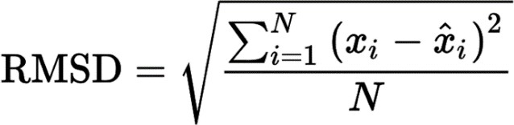

A statistical tool for evaluating mistakes between pairs of data that represent the same phenomena is the mean absolute error (MAE). Instances of such observations include comparisons of Y and X, such as expected against observed, following time versus starting time, and one measuring approach versus another measurement technique. By dividing the total absolute error values by the sample's size, MAE is determined.

The formula for MAE is:

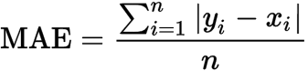

# OBSERVATIONS AND RESULTS

The suggested approach feeds the GraphRec model with information from user modelling and item modelling. Combining these aggregations enhances the models performance, resulting in decreasing RMSE value and higher overall performance, as indicated by the resultant RMSE value of 0.8110 in Table 3.

The model's performance is assessed against traditional recommender systems, traditional social recommendation systems, and deep neural network-based systems for recommendation. The representative norms for each category are listed below:

NeuMF [11]: an innovative collaborative filtering approach based on neural networks created for problems involving recommendation rating. For the purpose of rating prediction, the loss model is changed to the squared loss.

DeepSoR [37]: In order to forecast ratings, this model factors ratings using a probabilistic matrix after learning user representation from social interactions.

PMF [34]: a probability matrix factorization model with Gaussian distributions that solely utilizes the user-item rating matrix to represent latent features for users and things.

TrustMF [36]: By factorizing trust networks in accordance with the directional attribute of trust, this model employs matrix factorization to map people into two low-dimensional spaces, referred to as trusted space and trustee space.

SoReg [14]: To confine the matrix factorization framework, social regularization represents data from social networks as regularization terms.

SoRec [35]: The user-item rating matrix and the user-user social connections matrix are co- factorized by Social Recommendation.

SocialMF [17]: The matrix factorization framework for recommender systems under this model involves trust information and trust information transmission.

GraphRec [30]: This approach simulates user and item representation in social recommendation using a graph neural network to predict ratings.

While the other models use social suggestion, PMF and NeuMF are pure collective filtering methods that do not use data from social networks for rating predictions. DeepSoR and GraphRec, two contemporary neural network-based social recommendations, are also compared to the proposed model.

|  |  |  |  |  |  |
| --- | --- | --- | --- | --- | --- |
| Datasets | | Toy Dataset(80%) | | Toy Dataset(60%) | |
| Metrics | | RMSE | MAE | RMSE | MAE |
|  | NeuMF | 1.0617 | 0.8062 | 1.0824 | 0.8251 |
|  | DeepSoR | 1.0316 | 0.7739 | 1.0437 | 0.7813 |
|  | PMF | 1.1238 | 0.9021 | 1.1967 | 0.9520 |
|  | TrustMF | 1.0479 | 0.7690 | 1.0543 | 0.7681 |
| Algorithms | SoReg | 1.0848 | 0.8611 | 1.0947 | 0.8987 |
|  | SoRec | 1.0652 | 0.8410 | 1.0738 | 0.8489 |
|  | SocialMF | 1.0501 | 0.0.8270 | 1.0592 | 0.8353 |
|  | GraphRec | 0.8510 | 0.6734 | 0.9931 | 0.6540 |

## Table 3: Comparison of the performance of various recommender systems

The popular Python neural network framework PyTorch was used to put the suggested strategy into practice. x% of the dataset was utilized as a training set, (1-x%)/2 as the validation set, and (1- x%)/2 as the set to be tested for the outcome comparison in order to construct a model and learn its parameters. For each dataset, the numerical value of x was changed between 80% and 60%.

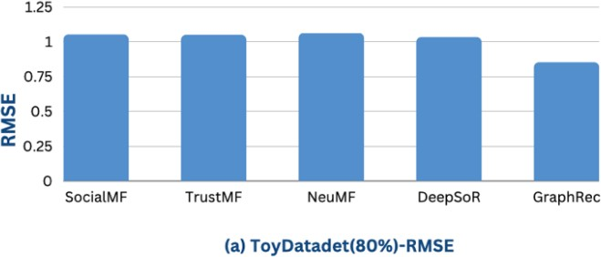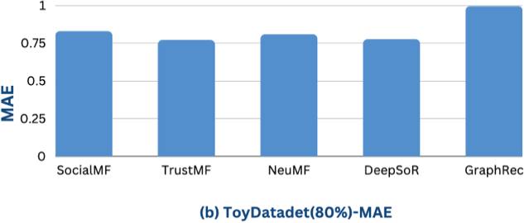

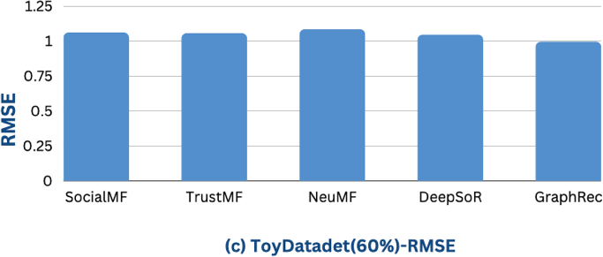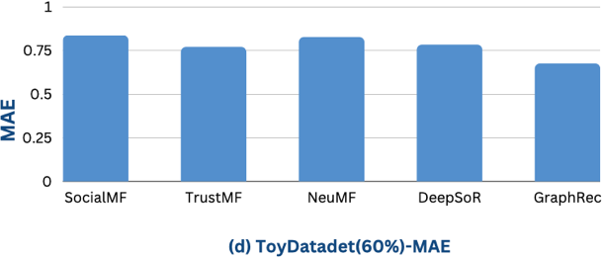

## Figure 4: Effect of linked peers, user opinions, and item graph on Toydataset.

For each technique, several values for learning rate, batch size, and embedding size (d) were evaluated. To create the item-item implicit network, several values of k for the most comparable items were also examined. The total rating error prediction, which includes RMSE and MAE for all techniques on the Toy dataset, is displayed in Table 3. The following findings were recorded:

* SoRec, SoReg, SocialMF, and TrustMF outperformed PMF. While PMF only uses rating data, the other methods use both rating and social network data, indicating the complementary nature of social network information for recommendations.
* NeuMF outperformed PMF, indicating the usefulness of neural network models for recommendation systems.
* DeepSoR outperformed SoReg, SoRec, TrustMF, and SocialMF, indicating the power of neural network models for recommendation systems.
* GNNs were found to be effective for representation learning for graph data due to their ability to incorporate information about nodes and topological structure.

The usefulness of the model components for combining rating and social network data is demonstrated by the proposed model's persistent outperformance of all baselines, including DeepSoR. Contrary to GraphRec, the suggested model clearly incorporates connections between items, taking into account both viewpoints and interaction within the user-item graph.

The study concluded that information from social networks and an item's neighbors is useful for suggestions. The suggested framework surpasses the representative baselines, and graph neural network models can enhance recommendation performance. The study makes the case that the model's elements are crucial to its performance and should be further investigated.

# CONCLUSION AND FUTURE WORK

In this paper, a paradigm for social recommendation rating prediction using Graph Neural Networks is proposed. To enhance the representations of user and item in the graphical representation of data, the framework suggests several aggregation techniques. The model considers user feedback when creating the graph of user and item. In addition, an attention mechanism is suggested to consider the various social relationships' strengths while modelling social graphs. In

order to profile things, the framework also specifically takes item-to-item connections into account.

The results show that the model's performance may be enhanced by including extensive user social relationships and item interactions. Additionally, using user social connections improves imputation performance and lowers RMSE values. Even though things also include characteristics and knowledge graphs, this study solely takes user-item interactions into account while building the item-item graph. The recommender systems might be improved even further by adding more side information. In order to create item-item graphs, it would be important to research ways to incorporate more side information.

# REFERENCES

1. van den Berg, Rianne and Kipf, Thomas N and Welling, Max ,” Graph Convolutional Matrix Completion” 2017 , arXiv preprint arXiv:1706.02263.
2. Z. Guo and H. Wang, & quot; A Deep Graph Neural Network-Based Mechanism for Social Recommendations, & quot; in IEEE Transactions on Industrial Informatics, vol. 17, no. 4, pp. 2776-2783, April 2021, doi:10.1109/TII.2020.2986316.
3. V. N. Ioannidis, A. S. Zamzam, G. B. Giannakis and N. D.Sidiropoulos, &quot;Coupled Graphs and Tensor Factorization for Recommender Systems and Community Detection, & quot; in IEEE Transactions on Knowledge and Data Engineering, vol. 33, no. 3, pp. 909- 920, 1 March 2021, doi:10.1109/TKDE.2019.2941716.
4. Y. Koren, R. Bell, and C. Volinsky, “Matrix factorization techniques for recommender systems,” Computer, vol. 42, no. 8, 2009
5. X. He, L. Liao, H. Zhang, L. Nie, X. Hu, and T. Chua, “Neural collaborative filtering,” in Proceedings of the 26th International Conference on World Wide Web, WWW, 2017, pp. 173–182.
6. J. Tang, X. Hu, and H. Liu, “Social recommendation: a review,” Social Network Analysis and Mining, vol. 3, no. 4, pp. 1113–1133, 2013
7. X. Wang, W. Lu, M. Ester, C. Wang, and C. Chen, “Social recommendation with strong and weak ties,” in Proceedings of the 25th ACM International on Conference on
8. Willmott, Cort J.; Matsuura, Kenji (December 19, 2005). "Advantages of the mean absolute error (MAE) over the root mean square error (RMSE) in assessing average model performance". Climate Research. 30: 79–82. doi:10.3354/cr030079.
9. X. Zhao, L. Xia, L. Zhang, Z. Ding, D. Yin, and J. Tang, “Deep reinforcement learning for page-wise recommendations,” in Proceedings of the 12th ACM Recommender Systems Conference. ACM, 2018, pp. 95–103.
10. Y. Koren, R. Bell, and C. Volinsky, “Matrix factorization techniques for recommender systems,” Computer, vol. 42, no. 8, 2009.
11. X. He, L. Liao, H. Zhang, L. Nie, X. Hu, and T. Chua, “Neural collaborative filtering,” in Proceedings of the 26th International Conference on World Wide Web, WWW, 2017, pp. 173–182.
12. J. Tang, X. Hu, and H. Liu, “Social recommendation: a review,” Social Network Analysis and Mining, vol. 3, no. 4, pp. 1113–1133, 2013.
13. Z. Zhao, Q. Yang, H. Lu, T. Weninger, D. Cai, X. He, and Y. Zhuang, “Social- aware movie recommendation via multimodal network learning,” IEEE Transactions on Multimedia, vol. 20, no. 2, pp. 430–440, 2018
14. H. Ma, D. Zhou, C. Liu, M. R. Lyu, and I. King, “Recommender systems with social regularization,” in Proceedings of the fourth ACM international conference on Web Search and Data Mining. ACM, 2011, pp. 287–296.
15. X. Wang, W. Lu, M. Ester, C. Wang, and C. Chen, “Social recommendation with strong and weak ties,” in Proceedings of the 25th ACM International on Conference on Information and Knowledge Management. ACM, 2016, pp. 5–14.
16. J. Tang, S. Wang, X. Hu, D. Yin, Y. Bi, Y. Chang, and H. Liu, “Recommendation with social dimensions,” in AAAI, 2016, pp. 251–257.
17. M. Jamali and M. Ester, “A matrix factorization technique with trust propagation for recommendation in social networks,” in Proceedings of the fourth ACM conference on Recommender systems. ACM, 2010, pp. 135–142.
18. T. N. Kipf and M. Welling, “Semi-supervised classification with graph convolutional networks,” in International Conference on Learning Representations (ICLR), 2017.
19. W. Hamilton, Z. Ying, and J. Leskovec, “Inductive representation learning on large graphs,” in Advances in Neural Information Processing Systems, 2017, pp. 1024– 1034.
20. M. Defferrard, X. Bresson, and P. Vandergheynst, “Convolutional neural networks on graphs with fast localized spectral filtering,” in Advances in Neural Information Processing Systems, 2016, pp. 3844–3852.
21. J. Bruna, W. Zaremba, A. Szlam, and Y. LeCun, “Spectral networks and locally connected networks on graphs,” arXiv preprint arXiv:1312.6203, 2013.
22. Y. Ma, S. Wang, C. C. Aggarwal, and J. Tang, “Graph convolutional networks with eigenpooling,” in Proceedings of the 25th ACM SIGKDD International Conference on Knowledge Discovery & Data Mining. ACM, 2019.
23. M. Schlichtkrull, T. N. Kipf, P. Bloem, R. Van Den Berg, I. Titov, and M. Welling, “Modeling relational data with graph convolutional networks,” in European Semantic Web Conference. Springer, 2018, pp. 593–607.
24. D. Nathani, J. Chauhan, C. Sharma, and M. Kaul, “Learning attention-based embeddings for relation prediction in knowledge graphs,” in Proceedings of the 57th Annual Meeting of the Association for Computational Linguistics (ACL), 2019.
25. M. Kampffmeyer, Y. Chen, X. Liang, H. Wang, Y. Zhang, and E. P. Xing, “Rethinking knowledge graph propagation for zero-shot learning,” in Proceedings of the IEEE Conference on Computer Vision and Pattern Recognition, 2019, pp. 11 487–11 496.
26. C.-W. Lee, W. Fang, C.-K. Yeh, and Y.-C. Frank Wang, “Multi-label zero-shot learning with structured knowledge graphs,” in Proceedings of the IEEE Conference on Computer Vision and Pattern Recognition, 2018, pp. 1576–1585.
27. S. K. Sahu, F. Christopoulou, M. Miwa, and S. Ananiadou, “Inter-sentence relation extraction with document-level graph convolutional neural network,” in Proceedings of the 57th Annual Meeting of the Association for Computational Linguistics (ACL), 2019.
28. G. Linden, B. Smith, and J. York, “Amazon. com recommendations: Item-to-item collaborative filtering,” IEEE Internet computing, no. 1, pp. 76–80, 2003.
29. M. Deshpande and G. Karypis, “Item-based top-n recommendation algorithms,”

ACM Transactions on Information Systems (TOIS), vol. 22, no. 1, pp. 143–177, 2004

1. W. Fan, Y. Ma, Q. Li, Y. He, E. Zhao, J. Tang, and D. Yin, “Graph neural networks for social recommendation,” in The World Wide Web Conference, ser. WWW ’19. ACM, 2019, pp. 417–426.
2. C. Chen, M. Zhang, Y. Liu, and S. Ma, “Neural attentional rating regression with review-level explanations,” in Proceedings of the 27th International Conference on World Wide Web, 2018, pp. 1583–1592.
3. M. McPherson, L. Smith-Lovin, and J. M. Cook, “Birds of a feather: Homophily in social networks,” Annual review of sociology, vol. 27, no. 1, pp. 415–444, 2001.
4. P. V. Marsden and N. E. Friedkin, “Network studies of social influence,” Sociological Methods & Research, vol. 22, no. 1, pp. 127–151, 1993.
5. R. Salakhutdinov and A. Mnih, “Probabilistic matrix factorization,” in 21th Conference on Neural Information Processing Systems, vol. 1, no. 1, 2007, pp. 2–1.
6. H. Ma, H. Yang, M. R. Lyu, and I. King, “Sorec: social recommendation using probabilistic matrix factorization,” in Proceedings of the 17th ACM conference on Information and Knowledge Management. ACM, 2008, pp. 931–940.
7. B. Yang, Y. Lei, J. Liu, and W. Li, “Social collaborative filtering by trust,” IEEE transactions on pattern analysis and machine intelligence, vol. 39, no. 8, pp. 1633–1647, 2017.
8. W. Fan, Q. Li, and M. Cheng, “Deep modeling of social relations for recommendation,” in AAAI, 2018.
9. R. v. d. Berg, T. N. Kipf, and M. Welling, “Graph convolutional matrix completion,” arXiv preprint arXiv:1706.02263, 2017.
10. X. Wang, X. He, M. Wang, F. Feng, and T.-S. Chua, “Neural graph collaborative filtering,” in Proceedings of the 42nd international ACM SIGIR conference on Research and development in Information Retrieval, 2019, pp. 165–174.
11. X. Wang, X. He, L. Nie, and T.-S. Chua, “Item silk road: Recommending items from information domains to social users,” in Proceedings of the 40th International ACM SIGIR conference on Research and Development in Information Retrieval. ACM, 2017, pp. 185–194.
12. S. Deng, L. Huang, G. Xu, X. Wu, and Z. Wu, “On deep learning for trust-aware recommendations in social networks,” IEEE transactions on neural networks and learning systems, vol. 28, no. 5, pp. 1164–1177, 2017.
13. F. Monti, M. Bronstein, and X. Bresson, “Geometric matrix completion with recurrent multi-graph neural networks,” in Advances in Neural Information Processing Systems, 2017, pp. 3700–3710.
14. Y. Wei, X. Wang, L. Nie, X. He, R. Hong, and T.-S. Chua, “Mmgcn: Multi-modal graph convolution network for personalized recommendation of micro-video,” in Proceedings of the 27th ACM International Conference on Multimedia, 2019, pp. 1437– 1445